**Gujarat Technological University**

Chandkheda, Ahmedabad

Affiliated

**VVP Engineering College, Rajkot**

A report on

**Data Analysis System**

**For Enterprises**

Under the course of

**DESIGN ENGINEERING-1A (31130008)**

**B.E SEM-3**

(Computer Engineering)

Submitted by:

|  |  |  |
| --- | --- | --- |
| Sr. No. | Name of student | Enrolment No. |
| 1 | Vachhani Dhruv Hiteshbhai | 180470107059 |
| 2 | Koradia Sharwil Ashwinbhai | 180470107029 |
| 3 | Makwana Dishen Alpeshbhai | 180470107035 |

**Prof. Maulik Dhamecha**  **Dr. Tejas Patalia**

(HOD)

(Assistant Prof.)

**Academic Year**

(2019-20)

**Gujarat Technological University**

Chandkheda, Ahmedabad

Affiliated

**VVP Engineering College, Rajkot**

**CERTIFICATE**

This is to certify that the students namely **Dhruv Vachhani (180470107059), Sharwil Koradia (180470107029) and Dishen Makwana (180470107035)** of **B.E. II (Computer Engineering) Semester III** have successfully completed the course work and related tasks for the course of **Design Engineering 1A (3130008)** during the academic term ending in the month of October 2019.

Date: Place: Rajkot

**Prof. Maulik Dhamecha**  **Dr. Tejas Patalia**

(Assistant Prof.)

(HOD)

**Acknowledgement**

I am deeply grateful of my guide **Prof. Maulik Dhamecha**, Assistant Professor, Department of Computer Engineering, VVP Engineering College, for his guidance and help in the successful completion of this project. He has been a constant source of encouragement and inspiration for which I heartily thank him.

I would also like to thank **Dr. Tejas Patalia**, Head of Department, Department of Computer Engineering who provided valuable suggestions that helped me gain deeper insight in the subject and whose attitude towards education disciplined me to take my work seriously.

I would also like to thank the non - teaching staff for their help in the project.

Lastly, I would like to thank my parents and God Almighty for their support and pious blessings.

**Contents**

Sr. no Topics Page No.

1. Introduction………………………………….. 5
2. AEIOU Framework............................ 6-7
3. Mind Mapping……………………………. 8
4. Ideation Canvas…………………………… 9-10
5. Product Development Canvas……………… 11-12
6. Empathy Canvas………………………….. 13-14
7. Learning Need Matrix…………………………. 15
8. Prototype………………………………….. 16
9. Plagiarism Report………………. 17
10. Conclusion………………………… 18

**1. Introduction**

Design Thinking is the methodology used by designers to solve complex and real world problems easily. Logic, imagination, creative thinking, systemic reasoning and to explore for solutions, these types of capabilities are developed due to design thinking. It is used to find solutions of an undesired situation.

We had done some observations in small enterprises that they find difficulty in managing the data on paper. So based on these observations and some estimation we have chosen this topic as our project. Our main aim behind this project was to reduce the paperwork as much as possible, which will help to maintain the data properly. All the information, facilities and data required by the enterprises are just one click away from them because of this project. Data management, call/lead management, backup and recovery of data and other facilities are available.

This subject helps to build up ideas of your own. It is important to develop creative thinking and to find solutions of problems in any situation. It develops a student in an engineer and improve their designing skills.

As we all know each other very well so we decided to work together on this project. As we are aware of each other it becomes easy to share your ideas and thoughts. We have to maintain the logbook, in which we have to note down what we have done and on which date/day. So we can keep record of the work that we have done and it is important to note it down.

**2. AEIOU Framework**

* Activities: It represents which type of activities can be done in the software. Most of the basic activities are covered in it.
* Environment: It represents in which type of area or environment it is used i.e. the place or location.
* Interaction: It includes the interactions taking place between people by the use of this software. How technical interactions will take place are mentioned in it.

* Objects: It includes which primary objects are required for building of the software.
* Users: It gives information that by whom this software will be used.

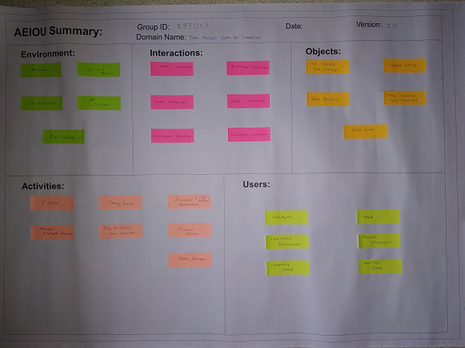

**3. Mind Mapping**: It is a technique that is generally used by engineers and designers use to express their ideas on paper. It is used to express ideas graphically. It is a hierarchical representation of relationships among the parts of the main topic or ideas. Mind map is generally made up of links of various ideas connected to the main topic. It is similar to that of ‘Spider Diagrams’ as all sub ideas are connected to the main idea through the links. It is a simple and a fast way of representing your creative idea on the paper. There is not any method to draw a mind map, as everyone represents their ideas differently.

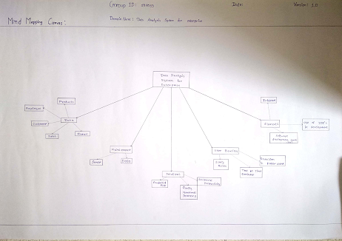

**4. Ideation Canvas**: It consists of different parts which are people, activities, situation/context/location and props/possible solutions.

1. People: All types of users who will be using the software are covered in this part.

* HR manager
* Financial Manager
* Administrator
* Advisor

These are some of the peoples who will be effectively using it.

1. Activities: Most of the activities which are required in the small offices or enterprises are covered in this topic.

* Employee Attendance
* Sales report in form of pie chart
* Priority based services to customer
* Record of working hours
* Customer Feedback

These all types of activities are covered in the system.

1. Situation/Context/Location: What is the situation, location and context based on the activities are covered in this part.

* Server Down
* Work Load
* Enterprises
* Small scale industries
* Optimization

These are some of the situation, context and location which can be introduced to the user.

1. Props/Possible Solutions: In this part, due to the introduction of software which are the possible solutions of the problems are covered in it.

* Backup and recovery of data becomes easy.
* It ensures rise in productivity.
* Effectiveness of marketing increases.
* Monitoring of every work becomes easy.
* Auto escalation and alerts.

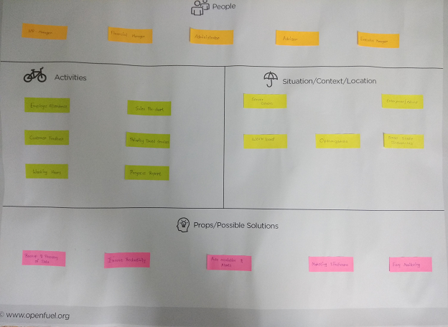

**5. Product Development Canvas**: What is the purpose for the development of this product, product experience, product functions, product features, components, customer revalidation and reject, redesign and retain are the topics covered in this sheet. It gives basic overview of the product.

1. Purpose: It defines the purpose behind the development of this project. Some basic purposes are given as below:

* To reduce the use of paper in corporate world.
* To make the data maintenance easy.
* To easily access all the data required by one person in one software.

1. Product Experience: The product experience by the user is written in this part. Some of the user’s best experience about the software are covered in this part. Best experiences are affordability of the software, user friendly system and the security of the software.
2. Product Functions: The basic and some of the functions performed by software are mentioned in this part. Daily report development, order management, graphs for sales and progress, customer details management and payment system for the user are some of the basic functions in the software.
3. Product Features: The primary features available to user which can be used easily are mentioned in this part. User friendly GUI, almost no or less maintenance required, Multi-tasking, automatic counting of profit and backup of data maintained are the basic features of it.
4. Customer Revalidation: The suggestions given by the user/customer of the software are mentioned in it. What can be introduced or can be added in the software for better use and to decrease the complexity are mentioned in it. SMS alert system and field tracking can be added. Mobile app for admin or CEO can be developed.
5. Components: What are the components required for its development or what are the basic components that user must have are mentioned in it. Server, Laptop/PCs, high speed internet, Customised DBMS and other hardware devices are required.

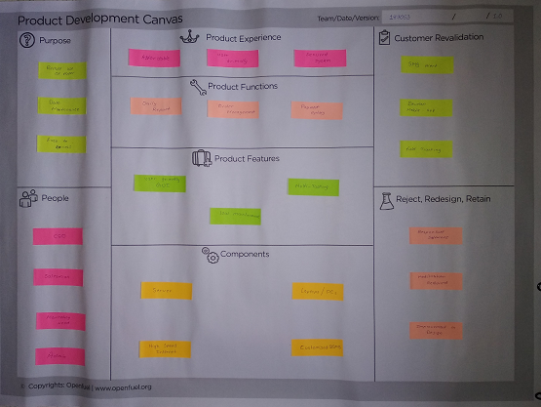

**6. Empathy Canvas**: Users, stakeholders and activities that are going to be carried out are mentioned in this sheet. Happy and sad experiences of the user are mentioned in the form of storyboarding.

1. User: Users who are going to use the software for their purpose are mentioned in it. Some of the basic users are employees, chairman, salesman, admin and head.
2. Stakeholders: Stakeholders are the indirect user of the software i.e. they are not using the software directly but they are included in the user. Non-tech staff of the company is included in it.
3. Activities: Activities which are going to be done by the user using the software are included in it. Some of the activities are:

* Product and service request list.
* Payment reminder.
* E-mail marketing of your respective enterprise.
* Meeting schedule arranged by the executives.
* Various graphs according to the requirement.

1. Storyboarding: In the storyboarding customer’s happy and sad experiences are mentioned. What the customer experienced about the product are written in it. The most common experiences are mentioned here.

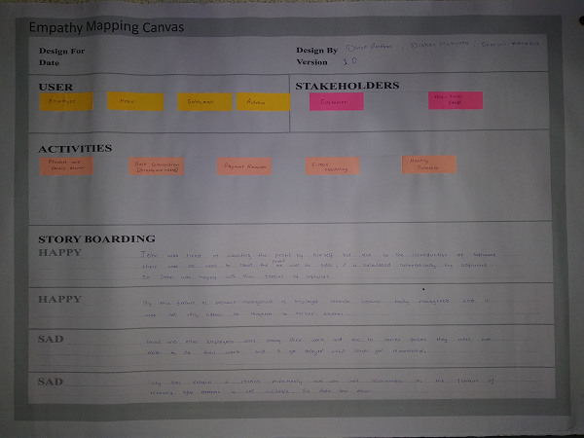

**7. Learning Need Matrix**: It helps to identify the requirements of learning at an early stage along with the priority and time duration required for a specific learning. It will mainly focus on the subjects of our branch most of which are included in your syllabus. It develops the concept of design learning and to solve the problems through it. It may include the learning of a specific skill and you can get mastered in it.

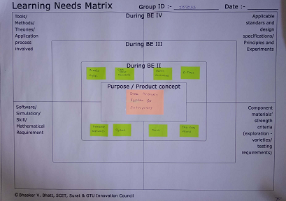

**8. Prototype**: It gives the rough idea of your product, how it will work and what it will look like. When the user will use the product how it will work step by step is mentioned in it. Whole procedure starting from login to ending at logout is mentioned or drawn in the sheet.

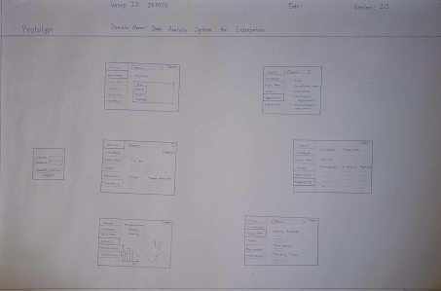

**9. Plagiarism Report**: It will check whether the content is copied from other sources or not. The given report is checked 1000 words per search.

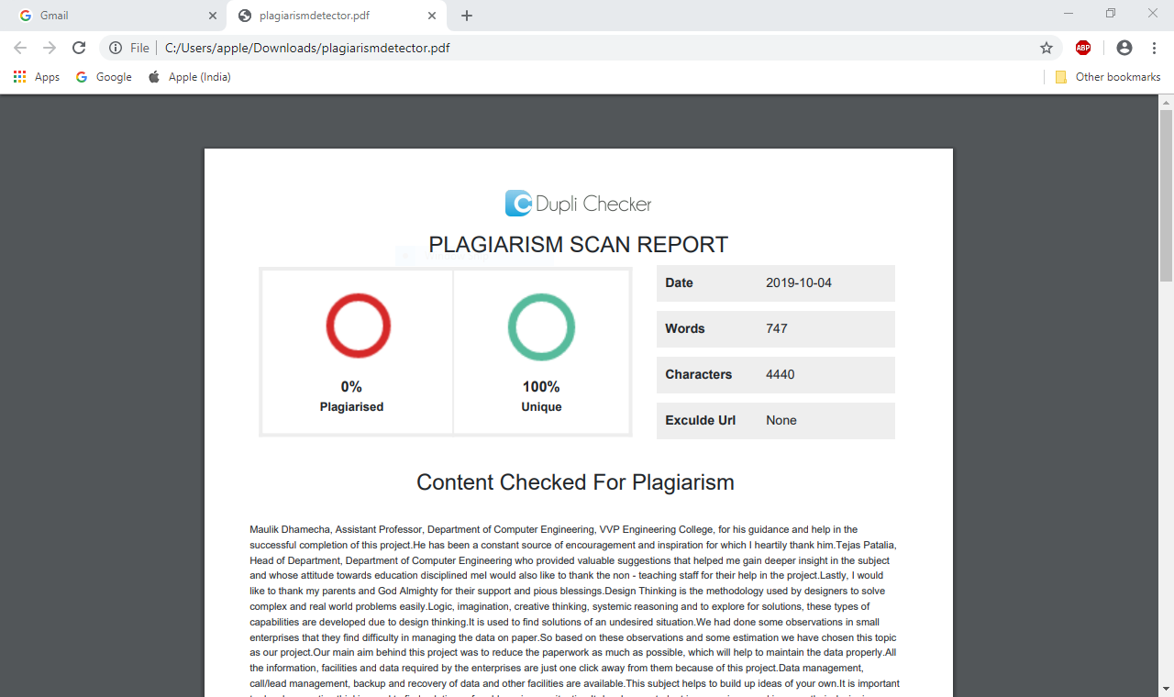

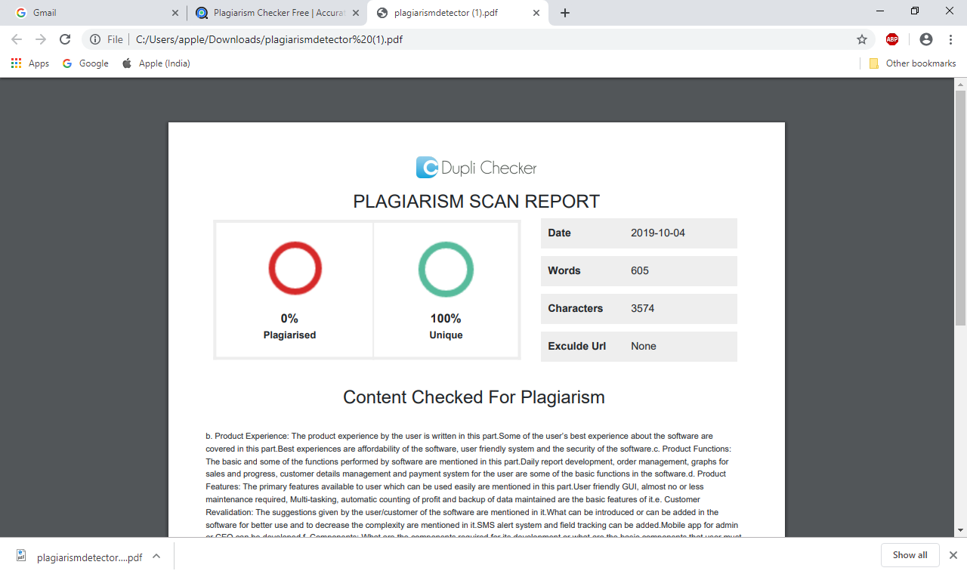

**Conclusion**

Our main aim behind this project was to reduce the paperwork and reduce the data management complexity and to increase productivity in the enterprises. From the following information that we collected we conclude that:

1. To use the software basic two need are there i.e. laptop/pc and high speed internet connectivity.
2. It can be used in small offices, industries and by accountants.
3. To develop it database concepts should be cleared.

Our product functions, features and some suggestions helped us to accomplish our project successfully and reducing the paperwork of enterprises.